Crash Course on the SkillTrack Database

We use AWS DynamoDB as our primary database. Our current setup has two tables. The main table is SkillTrackTable. Note that DynamoDB is a NoSQL database. It is not relational like a traditional SQL database. So all sorts of objects are represented in this singular table. Think of each row more like a JSON item more than a literal row as in a traditional SQL framework

Here is an example of the table the SkillTrack team in 2025-2026 ended up getting together in our development cycle.
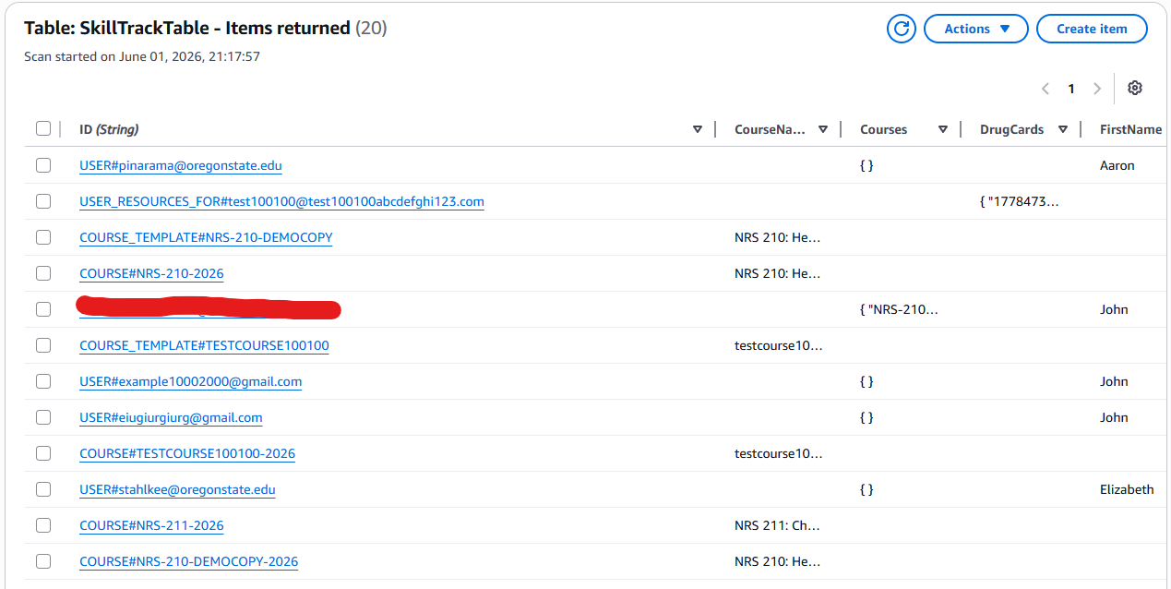
If you follow the instructions in the README in the root directory of the repository you should start with only a singular row. A row for a user that is an Admin. This is OK, as you use the app you will gradually make more. View the How to Call the Backend to see the different capabilities. Note that it is highly discouraged to edit the database directly. This is because due to the non-relational nature of this database, some pieces of data are in two or more places at once, and the code logic must ensure that these datas match, which the endpoints should do.

As a simple example. A USER that is a student has nested data that represent what courses they are enrolled in AND the course itself maintains a piece of data that maintains the student roster. These are not inherently tied by some relational connection, so the endpoints must manually make sure they match when relevant

The rest of this document will cover all types of data types. The very bottom of the doc will also cover the other table that is used, SkillTrackTokenTable.

Data Types for SkillTrackTable
Table of Contents of all Data Types:
- USER#
- USER_RESOURCES_FOR#
- COURSE_TEMPLATE#
- COURSE#

USER#
A user item on the table is used to store the data for a particular user. There are three main types of users. Student, Admin, and Teacher (note that the term Teacher and Instructor are used interchangeably throughout this project, but in terms of the database, the term Teacher is what is used to identify their role)
Here is what Teacher item on the table looks like:
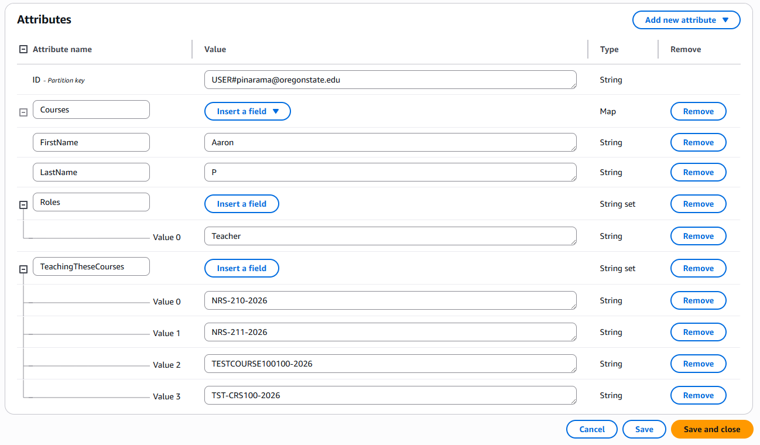
- *Connection Note: Note the section TeachingTheseCourses. This identifies the ID of the courses the teacher is teaching. Note that the corresponding COURSE# items for these courses also have a section that lists all the teachers emails. These should be in sync and match any time a modification is made to the courses a teacher is teaching. See the COURSE# section for more details on what it looks like on that end too.

Here is what an Admin item on the table looks like:
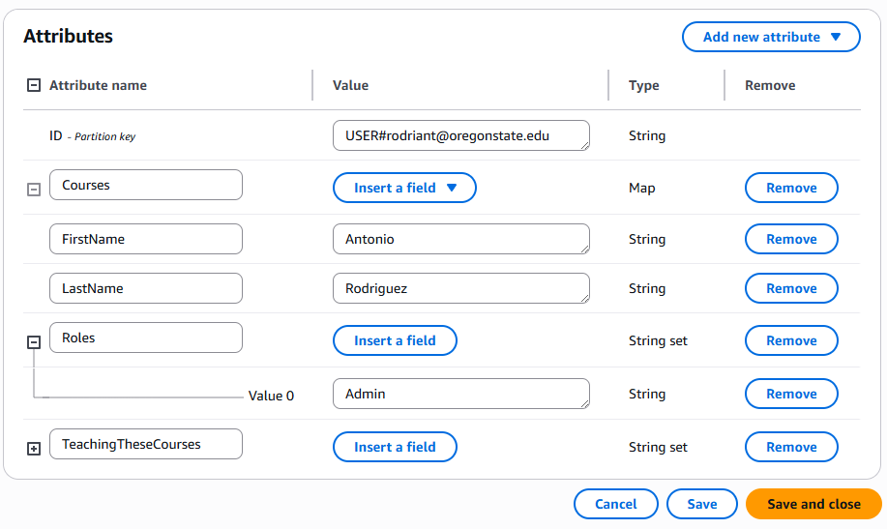
An admin may have a TeachingTheseCourses section, but it is not essential. And the regular admin UI does not currently (as of 6/1/2026) have a way to access the teacher check off UI anyhow.

Here is what a student Item looks like (Part1):
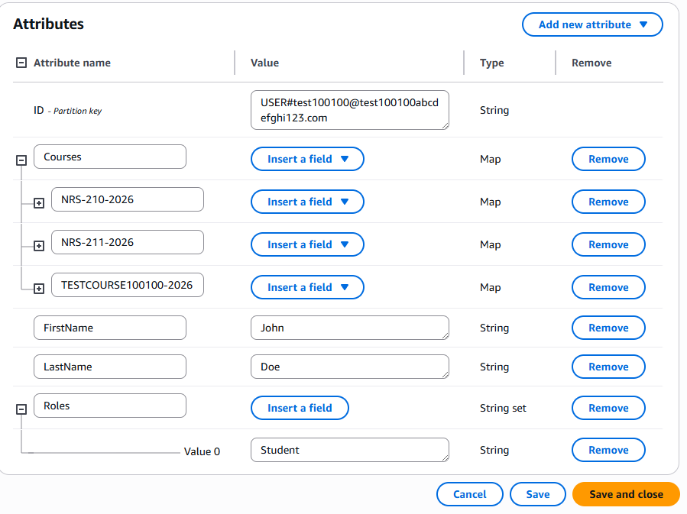
- *Connection Note: Similar to the teacher view, the Courses are listed here, and they are also listed in the student roster section of the corresponding COURSE#. These must match. See the COURSE# section for more details on what it looks like on that end too.

Student (Part2 – expanded courses list)
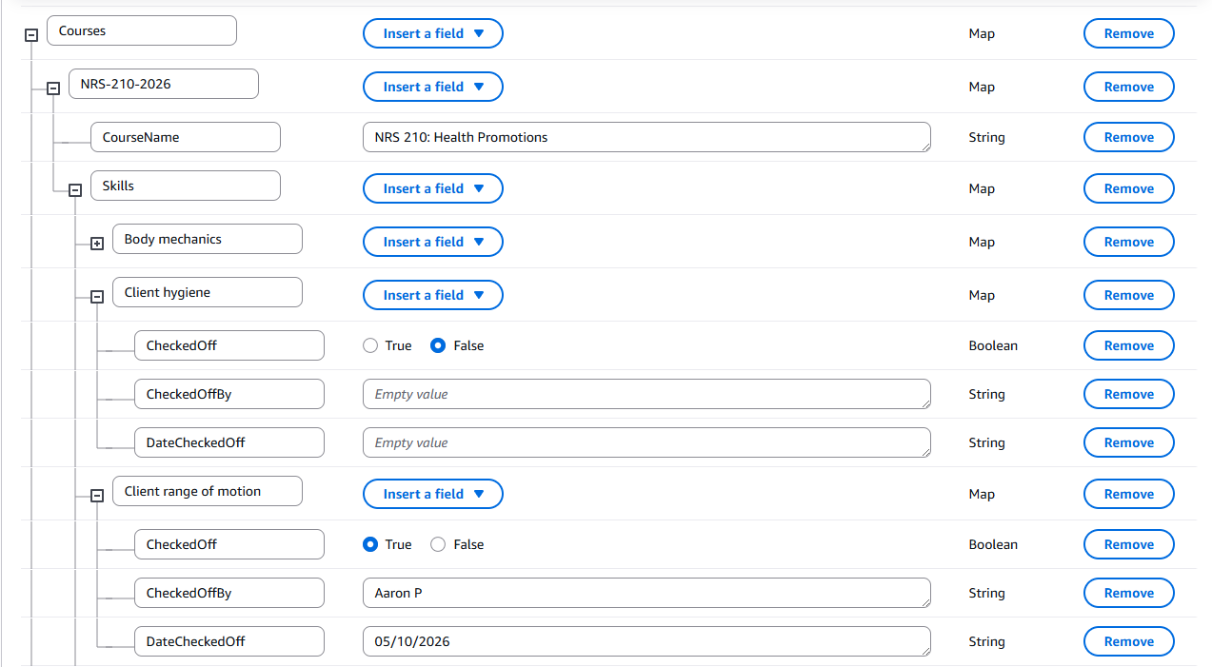
Notice how each course in the student item also hosts each skill and its checkoff status. The checkoff data is stored LOCALLY to each student. To make an analogy. Think of the checkoff data as being a paper that each student holds on too, and then a teacher goes to sign them off on it. To continue the analogy, the checkoff data IS NOT a central piece of paper that the teacher keeps in the classroom drawer.
One consequence of this is that if it is desired to change the particular skills for a particular course while the course has already started, you must also go into every currently enrolled student and modify their individual data entry to make sure it matches the course “master-list” of skills. There is currently no endpoint to modify a existing course skill list, but if that is something that you are interested in doing, you will have to consider that aspect.

USER_RESOURCES_FOR#
This is a separate entry that manages the drug cards for a particular user. This was made a seperate row/item to prevent the main user row from growing to big. Here is what it looks like, where the string of numbers is the unique ID for each drug card.
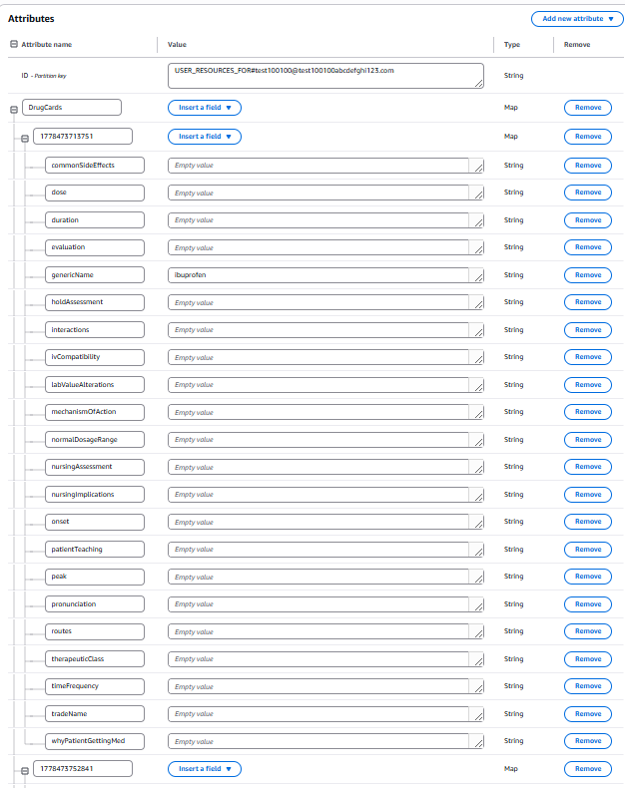
COURSE_TEMPLATE#
Course templates are templates that admins make that teachers then make courses from. So there may be a template for a particular course that is taught every Fall for example, so the admin makes the template one time, and each fall the teachers go ahead and make a particular COURSE# for it.
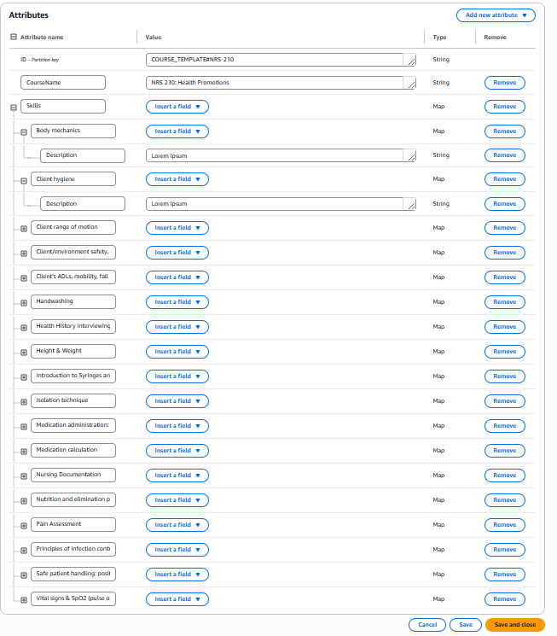

COURSE#
Here is what a course entry looks like (in two images)
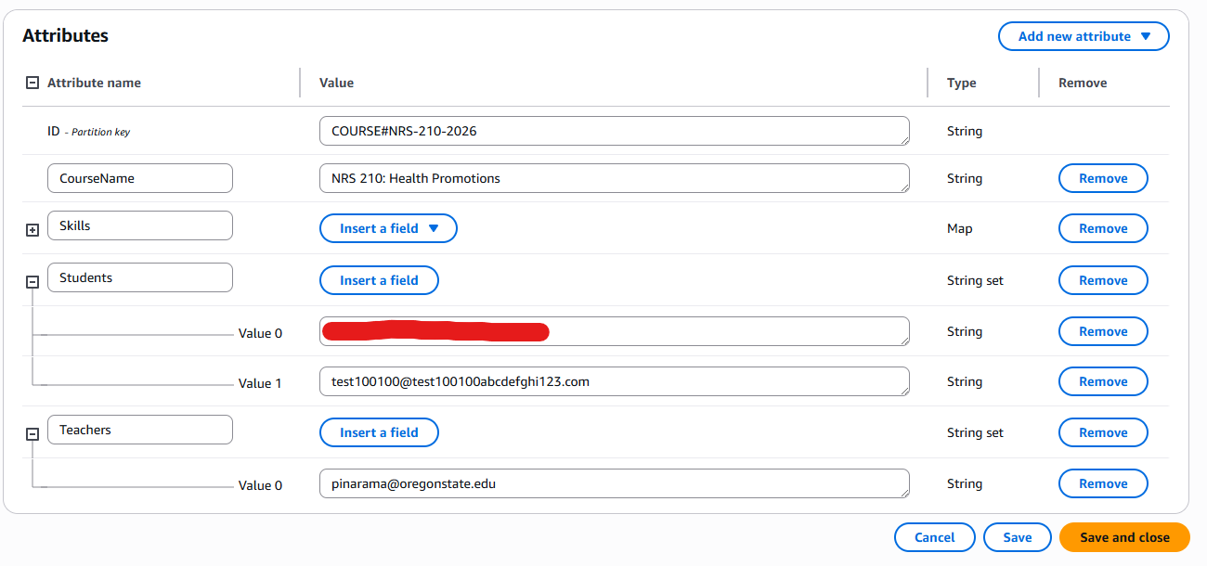

With expanded Skills
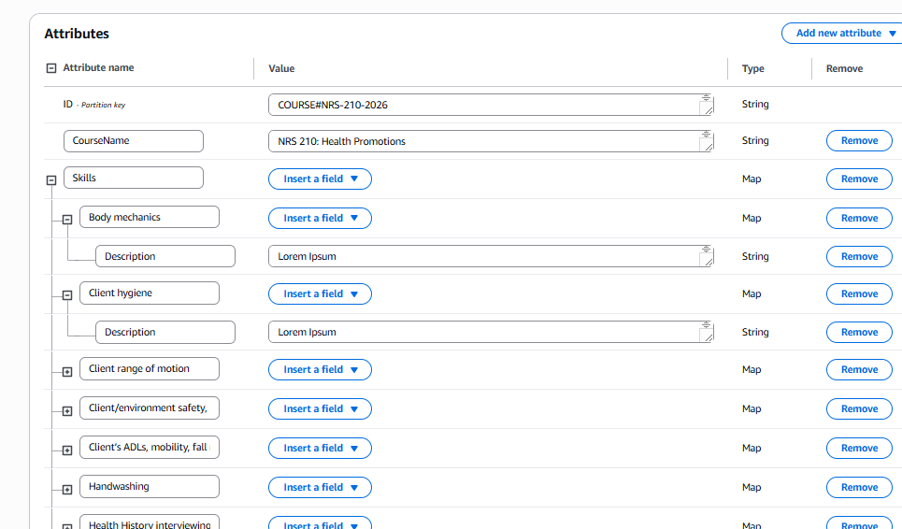
- *Connection Note: The listed students and teachers here, in their own individual #USER entries should also list the ID for the given course in their their Courses or TeachingTheseCourses section. Additionally, for a student the Courses entry should be comprehensive and list all the skills that can be checked off. You can review the /AddStudentToCourse code to see how this is accomplished when adding a student to the course.

SkillTrackTokenTable
Finally, the other table, SkillTrackTokenTable should also be mentioned. The only purpose of this table is to facilitate the QR code process. And is mainly used with the /FetchUserToken and /TokenToEmail endpoints. Review the Backend reference doc for more info. Here is what an entry on this table looks like:
